**.NET PRACTICAL**

Priya vaghasia

160470107061

Table of Contents

**PRACTICAL-1** 1

AIM : Introduction to c# 1

**PRACTICAL-2** 7

AIM: Inheritance 7

Program 1 7

Program 2 8

Program 3 9

Program 4 11

**PRACTICAL-3** 12

Program 1 12

Program 2 15

**PRACTICAL-4** 17

Program:1 17

**PRACTICAL-5** 19

Program 1 19

Program 2 19

Program 3 20

PRACTICAL-6 21

Program 1 21

PRACTICAL-7 30

Program-1 30

PRACTICAL-8 32

Program-1 32

# **PRACTICAL-1**

# AIM : Introduction to c#

Variables:

Initialization

Scope

Constant

Predefined Data Types

Value Types

Reference TYpes

Flow Control

Conditional Statements(if, switch)

Loop(for, while, dowhile, foreach)

Jump(goto, break, continue, return)

Eumerations

Passing Arguments

using System;

using System.Collections.Generic;

using System.Linq;

using System.Text;

using System.Threading.Tasks;

namespace aim

{

class Program

{

static int newint=100;

public enum TimeOfDay

{

Morning = 0,

Afternoon = 1,

Evening = 2

}

public static void Main(string[] args)

{

Console.WriteLine("\n integer types");

sbyte sb = 10;

short s = 33;

int i = 10;

long l = 33L;

byte b = 22;

ushort us = 33;

uint ul = 33u;

ulong ulo = 33ul;

Console.WriteLine("{0},{1},{2},{3},{4},{5},{6},{7}", sb, s, i, l, b, us, ul, ulo);

float f = 1.122345656767f;

double d = 12.1234455657878797;

Console.Write("\nFloat and Double:\n");

Console.WriteLine("{0} and \n{1}", f, d);

decimal dec=111.666666666666666666666M;

Console.WriteLine("decimal:\n{0} ",dec);

Console.WriteLine("\nBoolean:");

bool boolean =true;

Console.WriteLine("Status: " + boolean);

// Console.ReadLine();

char character ='d';

Console.WriteLine(character);

character = '\0';

Console.WriteLine("Now null: " + character);

object o1 = "Hi, I am ALICE";

object o2 = 15.3454365;

string strObj = o1 as string;

Console.WriteLine(strObj);

Console.WriteLine(o1.GetHashCode() + " " + o1.GetType());

Console.WriteLine(o2.GetHashCode() + " " + o2.GetType());

Console.WriteLine(o1.Equals(o2));

string s1, s2;

s1 = "this is string";

s2 = s1;

Console.WriteLine("S1 is: {0} and s2 is {1}", s1, s2);

s2 = "other string";

Console.WriteLine("S1 is: {0} and s2 is {1}", s1, s2);

s1 = "c:C:\\Users\\Dell\\source\\repos\\aim";

Console.WriteLine(s1);

s1 = @"c:C:\Users\Dell\source\repos\aim\aim";

Console.WriteLine(s1);

s1 = @"We can also write

like this";

Console.WriteLine(s1);

bool isZero;

Console.WriteLine("\nFlow Control: (if)\ni is " + i);

if (i == 10)

{

isZero = true;

Console.WriteLine("i is Zero {0}",isZero);

}

else

{

isZero = false;

Console.WriteLine("i is Non - zero");

}

int integerA = 1;

Console.WriteLine("\nSwitch:");

switch (integerA)

{

case 1:

Console.WriteLine("integerA = 1");

break;

case 2:

Console.WriteLine("integerA = 2");

//goto case 3;

break;

case 3:

Console.WriteLine("integerA = 3");

break;

default:

Console.WriteLine("integerA is not 1, 2, or 3");

break;}

WriteGreeting(TimeOfDay.Morning);

Console.WriteLine("Argument is: {0}",args[1]);

void WriteGreeting(TimeOfDay timeOfDay)

{

switch (timeOfDay)

{

case TimeOfDay.Morning:

Console.WriteLine("Good morning!");

break;

case TimeOfDay.Afternoon:

Console.WriteLine("Good afternoon!");

break;

case TimeOfDay.Evening:

Console.WriteLine("Good evening!");

break;

default:

Console.WriteLine("Hello!");

break;

} }

Console.WriteLine("Scope of Variables.\n1:");

int newint=0;

int j;

for (/*int*/ j = 0; j < 2; j++) //removing comment from for loop will raise error

{

//int j;

//uncomment above line to error "A local variable named 'j' cannot be declared in this

//scope because it would give a different meaning to 'j', which is already

//remove comments from the above line to see error "The expression being assigned to 'valConst2' must be constant"//used in a 'parent or current' scope to denote something else"

Console.Write("{0} {1}\n", newint, Program.newint);

}

Console.WriteLine("2:");

for (int k = 0; k < 3; k++)

{

Console.Write("{0} ", k);

}//Scope of k ends here

Console.Write("\n");

//Console.Write(k);

//uncomment above line to see error "The name 'k' does not exist in the current context"

for (int k = 3; k > 0; k--)

{

Console.Write("{0} ", k);

}//scope of k ends here again

Console.WriteLine("Constants");

const int valConst = 100; // This value cannot be changed.

Console.WriteLine("{0} is constant value", valConst);

//valConst = 45;

//uncomment above line to see error "The left-hand side of an assignment must be a variable, property or indexer"

//const only allow constant variables into the expression

const int valConst2 = valConst + 9 /* + j*/;

Console.WriteLine("Another Constant: {0}", valConst2);

Console.WriteLine("\nPredefined Data Types\n\nValue Types and Reference Types");

//Value Types

int vali = 2, valj = vali;

Console.WriteLine("vali is: {0} and valj is: {1}", vali, valj);

valj = 90;

Console.WriteLine("vali is: {0} and valj is: {1}", vali, valj);

//Referece Types

Vector x, y;

x = new Vector();

x.value = 3;

y = x;

Console.WriteLine("x is: {0} and y is:{1}", x.value, y.value);

y.value = 234;

Console.WriteLine("x is: {0} and y is:{1}", x.value, y.value);

//If a variable is a reference, it is possible to indicate that it does not refer to any object by setting its value to null:

y = null;

//Console.Write("Value for y is: " + y.value);

//uncomment above line to see runtime exception "System.NullReferenceException: Object reference not set to an instance of an object."

//CTS }

public class Vector

{

public int value;

}

}

}

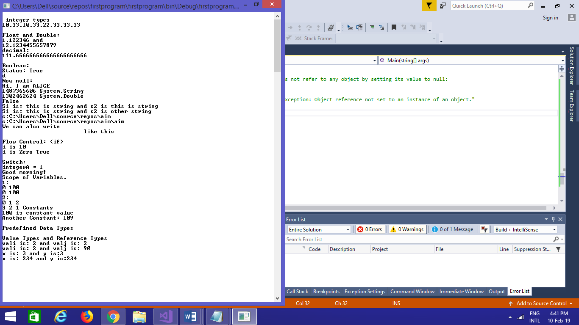

# **PRACTICAL-2**

# AIM: Inheritance

## Program 1

Perform following programs in c#.

1. Write console based program in code behind language VB or C# to print following pattern.

@ @ @ @ @

@ @ @ @

@ @ @

@ @

@

using System;

using System.Collections.Generic;

using System.Linq;

using System.Text;

using System.Threading.Tasks;

namespace practical2

{

class Program

{

static void Main(string[] args)

{

for(int i=5;i>0;i--)

{

for (int j = i; j > 0; j--)

{

Console.Write("@");

}

Console.WriteLine(" ");

}

Console.ReadKey();

}

}

}

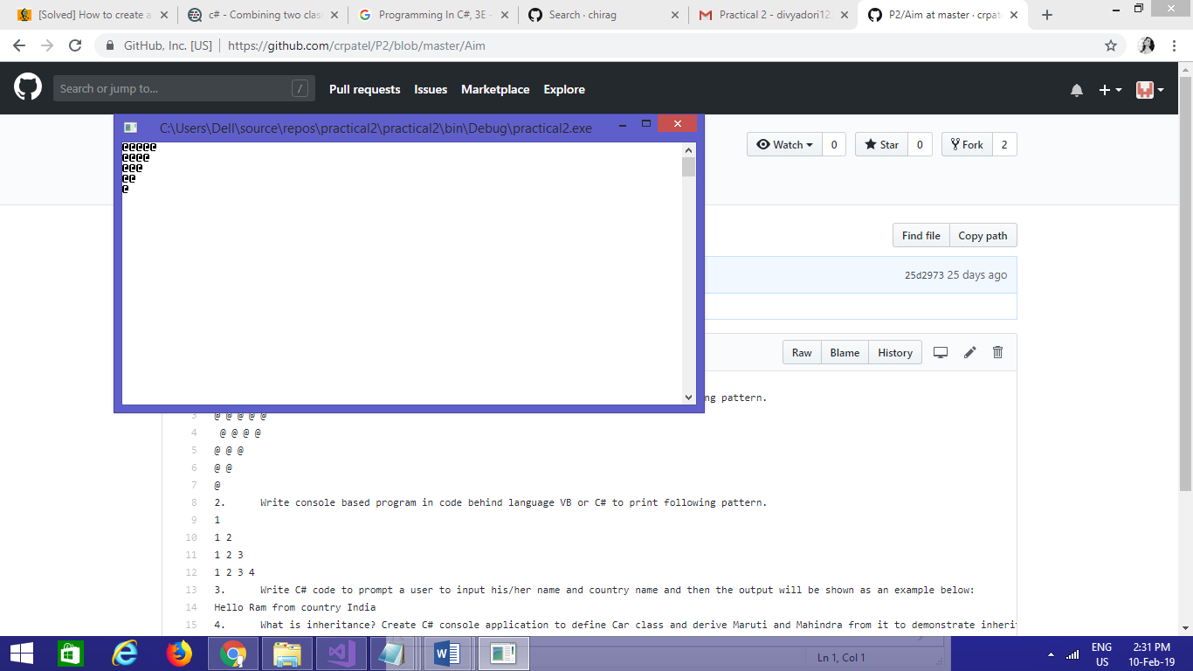

## Program 2

2. Write console based program in code behind language VB or C# to print following pattern.

1

1 2

1 2 3

1 2 3 4

using System;

using System.Collections.Generic;

using System.Linq;

using System.Text;

using System.Threading.Tasks;

namespace practical2._1

{

class Program

{

static void Main(string[] args)

{

for(int i=1;i<=5;i++)

{

for(int j=i;j>0;j--)

{

Console.Write("{0}",i);

}

Console.WriteLine("");

}

Console.ReadKey();

}

}

}

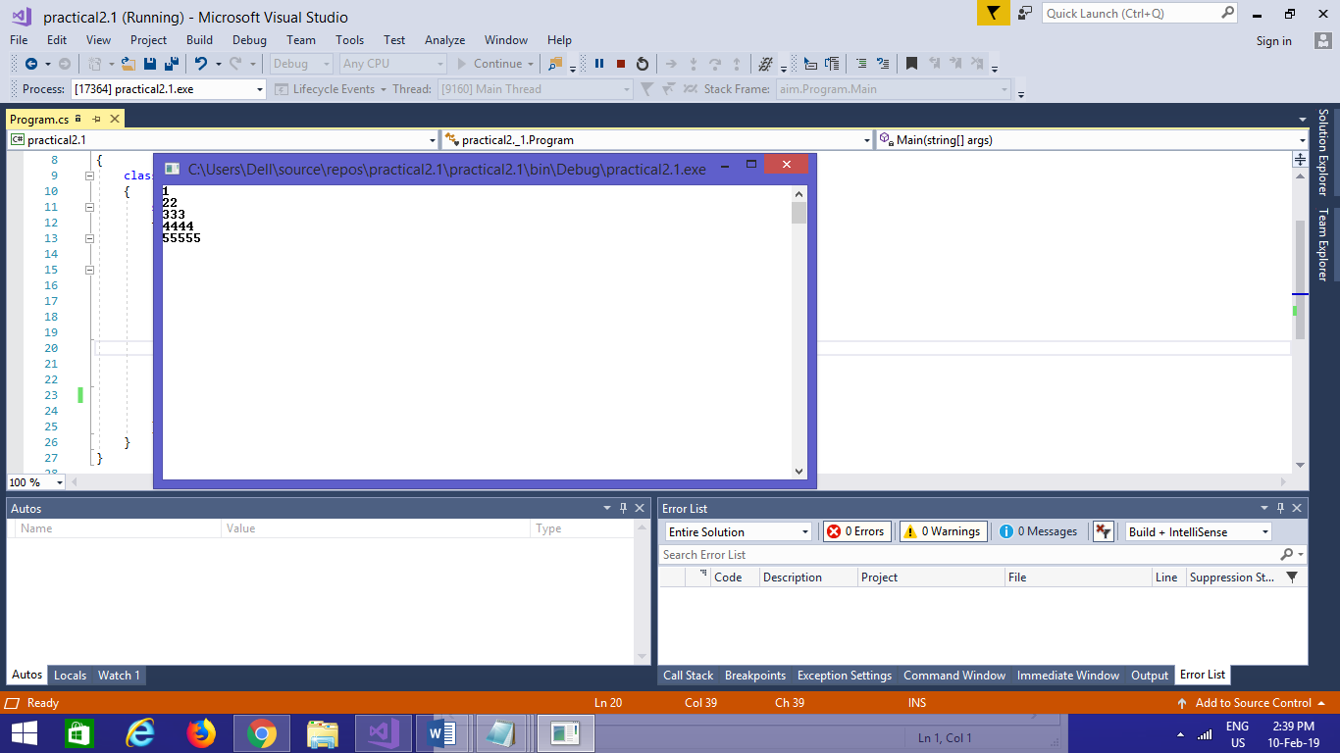

## Program 3

3. Write C# code to prompt a user to input his/her name and country name and then the output will be shown as an example below:

Hello Ram from country India

using System;

using System.Collections.Generic;

using System.Linq;

using System.Text;

using System.Threading.Tasks;

namespace practical2._2

{

class Program

{

static void Main(string[] args)

{

string name;

string country;

Console.WriteLine("enter your name:");

name=Console.ReadLine();

Console.WriteLine("enter your country:");

country = Console.ReadLine();

Console.WriteLine("hello {0} from country {1}",name,country);

Console.ReadKey();

}

}

}

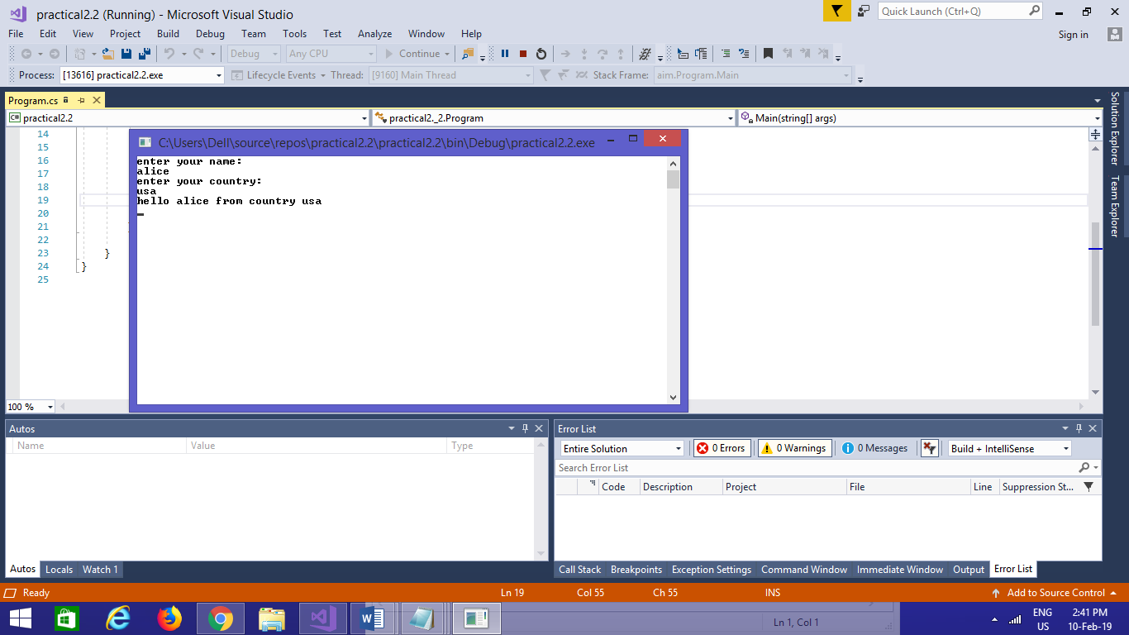

## Program 4

What is inheritance? Create C# console application to define Car class and derive Maruti and Mahindra from it to demonstrate inheritance.

using System;

using System.Collections.Generic;

using System.Linq;

using System.Text;

using System.Threading.Tasks;

namespace practical2._3

{

class car

{

public void Method1()

{

Console.WriteLine("this is the method of car class");

}

}

class maruti:car

{

public void method2()

{

Console.WriteLine("this is the method of maruti");

Console.ReadKey();

}

}

class mahindra:car

{

public void method3()

{

Console.WriteLine("this is the method of mahindra");

}

}

class Program

{

static void Main(string[] args)

{

mahindra m = new mahindra();

maruti m1 = new maruti();

m.Method1();

m1.Method1();

Console.ReadKey();

# **PRACTICAL-3**

AIM: Method & constructor overloading

## Program 1

Write a c# program to add two integers, two vectors and two metric using method overloading.

using System;

using System.Collections.Generic;

using System.Linq;

using System.Text;

using System.Threading.Tasks;

namespace p3

{

public class Add

{

public void add()

{

int[,] m1 = new int[50, 50];

int[,] m2 = new int[50, 50];

int[,] m3 = new int[50, 50];

Console.WriteLine("enter size of array:");

int size = Convert.ToInt32(Console.ReadLine());

Console.WriteLine("enter first array:");

for (int i = 0; i < size; i++)

{

for (int j = 0; j < size; j++)

{

m1[i, j] = Convert.ToInt32(Console.ReadLine());

}

}

Console.WriteLine("enter second array:");

for (int i = 0; i < size; i++)

{

for (int j = 0; j < size; j++)

{

m2[i, j] = Convert.ToInt32(Console.ReadLine());

}

}

for (int i = 0; i < size; i++)

{

for (int j = 0; j < size; j++)

{

m3[i, j] = m1[i, j] + m2[i, j];

}

}

Console.WriteLine("addition array:");

for (int i = 0; i < size; i++)

{

Console.Write("\n");

for (int j = 0; j < size; j++)

{

Console.Write("{0}\t", m3[i, j]);

}

Console.Write("\n");

}

}

public int add(int a, int b)

{

return (a + b);

}

}

public class Vector

{

public void add()

{

Console.WriteLine("enter first vector");

int x = Convert.ToInt32(Console.ReadLine());

int y = Convert.ToInt32(Console.ReadLine());

int z = Convert.ToInt32(Console.ReadLine());

Console.WriteLine("enter second vector");

int x1 = Convert.ToInt32(Console.ReadLine());

int y1 = Convert.ToInt32(Console.ReadLine());

int z1 = Convert.ToInt32(Console.ReadLine());

int x2 = x + x1;

int y2 = y + y1;

int z2 = z + z1;

Console.WriteLine("<" + x2 + "," + y2 + "," + z2 + ">");

}

}

class Program

{

static void Main(string[] args)

{

Add a1 = new Add();

Vector v1 = new Vector();

v1.add();

a1.add();

int res=a1.add(1, 2);

Console.Write("method overloading for addtion{0}",res);

Console.ReadLine();

}

}

}

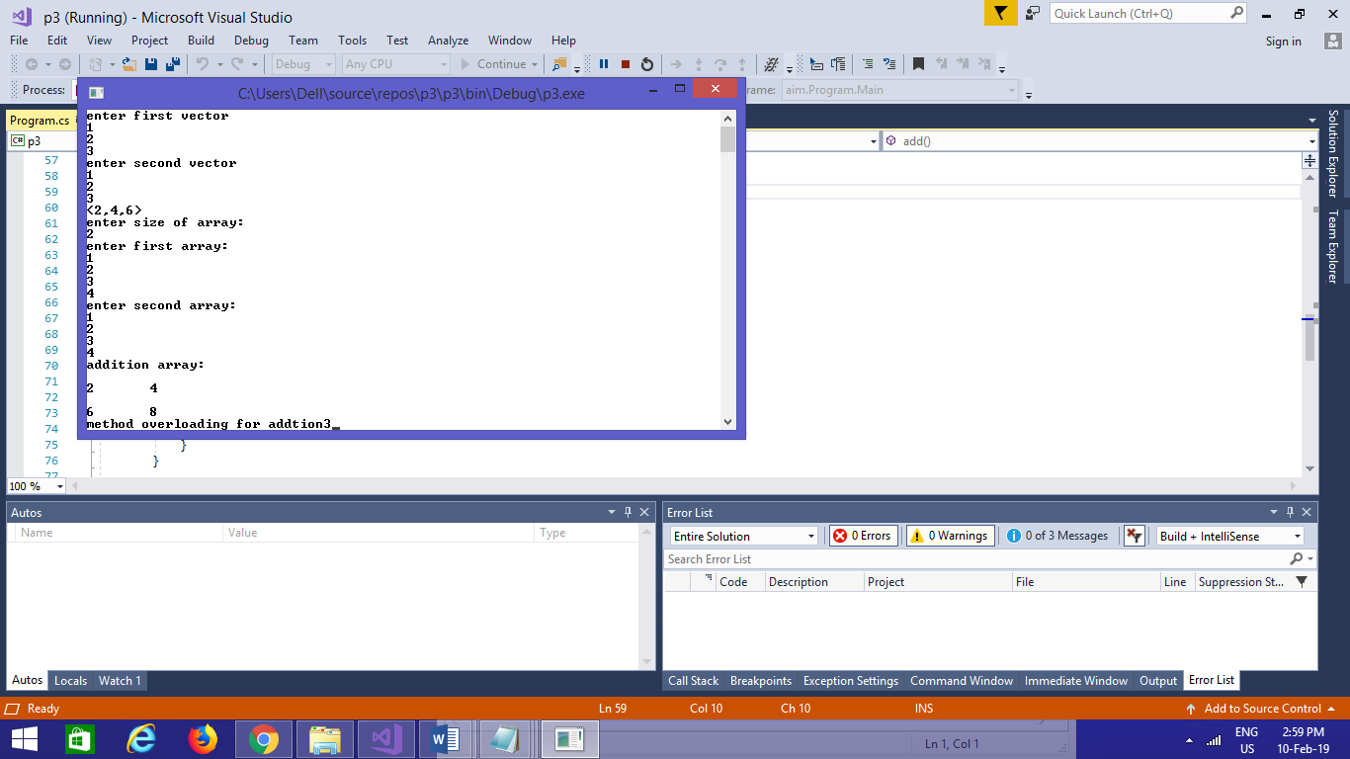

## Program 2

Write a c# program that create student object. Overload constror to create new instant with following details.

1. Name

2. Name, Enrollment

3. Name, Enrollment, Branch

using System;

using System.Collections.Generic;

using System.Linq;

using System.Text;

using System.Threading.Tasks;

using System.Reflection;

namespace p3a1

{

class Program

{

public int ID { get; set; }

public string Name { get; set; }

String name, branch;

int enrol;

public Program(String name)

{

this.name = name;

Console.WriteLine("constructor 1:" + name);

}

public Program(String name, int enrol)

{

this.name = name;

this.enrol = enrol;

Console.WriteLine("constructor 2:" + name + " " + enrol);

}

public Program(String name, int enrol, String branch)

{

this.name = name;

this.enrol = enrol;

this.branch = branch;

Console.WriteLine("constructor 3:" + name + " " + enrol + " " + branch);

}

static void Main(string[] args)

{

Program p1 = new Program("bob");

Program p2 = new Program("bob", 1);

Program p3 = new Program("bob", 1, "computer");

Console.ReadLine();

}

}

}

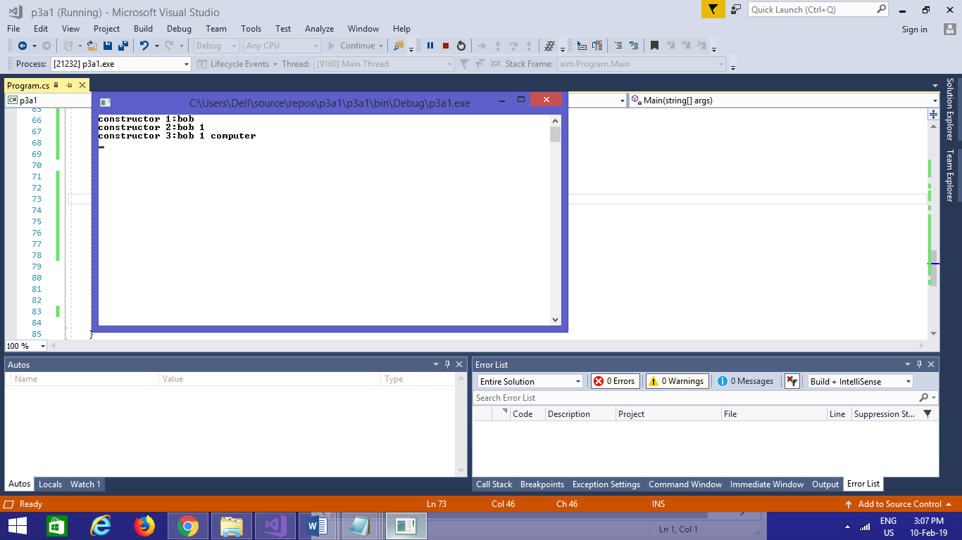

# **PRACTICAL-4**

AIM:find Methods, Properties and Constructors from class of running program

## Program:1

Using System;

using System.Reflection;

namespace ReflectionExample

{

class MainClass

{

static void Main()

{

Type T = Type.GetType("ReflectionExample.Customer");

MethodInfo[] methods = T.GetMethods();

foreach (MethodInfo method in methods)

{

Console.WriteLine(method.ReturnType + " " + method.Name);

}

PropertyInfo[] properties = T.GetProperties();

Console.WriteLine("\nProperties");

foreach (PropertyInfo property in properties)

{

Console.WriteLine(property.PropertyType+" "+ property.Name);

}

Console.WriteLine("\nConstructors");

ConstructorInfo[] constructors = T.GetConstructors();

foreach (ConstructorInfo constructor in constructors)

{

Console.WriteLine(constructor.ToString());

}

}

}

class Customer

{

public int ID { get; set; }

public string Name { get; set; }

public Customer(int ID, string Name)

{

this.ID = ID;

this.Name = Name;

}

public Customer()

{

this.ID = -1;

this.Name = string.Empty;

}

public void printID()

{

Console.WriteLine("ID is: {0}", this.ID);

}

public void printName()

{

Console.WriteLine("Name is: {0}", this.Name);

}

}

}

**OUTPUT:**

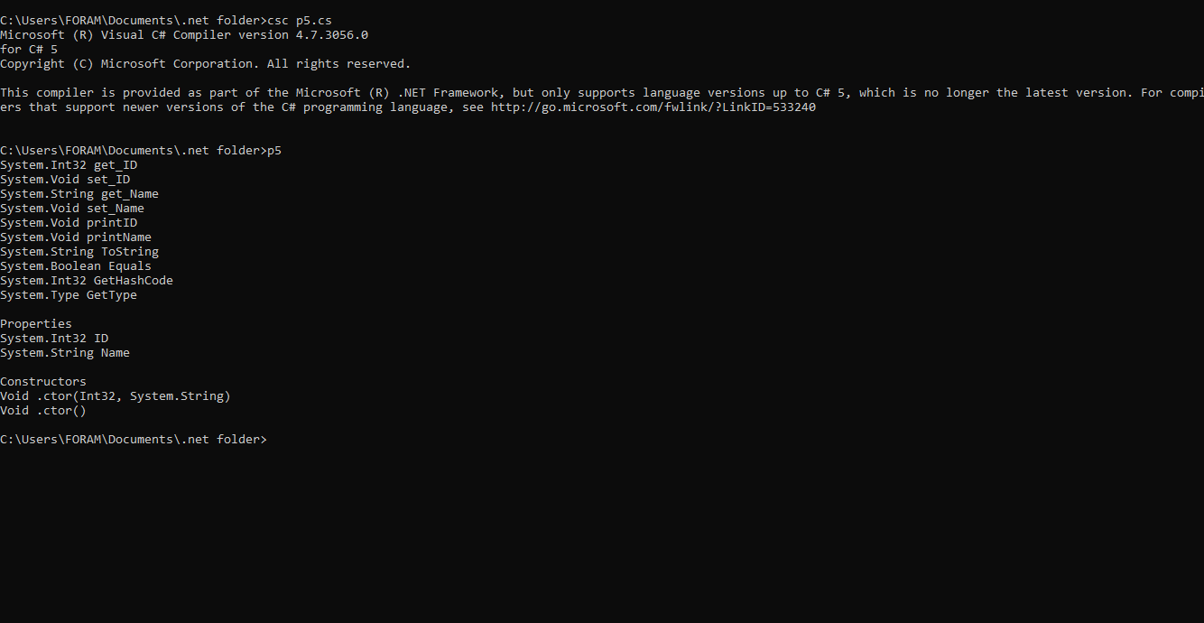

# **PRACTICAL-5**

Write a C# program to copy data from one file to another using StreamReader and StreamWriter class.

## Program 1

using System;

using System.IO;

class CopyFile

{

public static void Main()

{

string file1 = @"abc.txt";

string file2 = @"xyz.txt";

using (StreamReader reader = new StreamReader(file1))

using (StreamWriter writer = new StreamWriter(file2))

writer.Write(reader.ReadToEnd());

}

}

.Write a C# Program to Read Lines from a File until the End of File is Reached.

## Program 2

using System;

using System.IO;

public class CopyFileContain

{

public void copyFile(string file1, string file2)

{

using(StreamReader reader = new StreamReader(file1))

using (StreamWriter writer = new StreamWriter(file2))

{

string line = null;

while ((line = reader.ReadLine()) != null)

writer.WriteLine(line);

}

}

}

class Copy

{

public static void Main()

{

CopyFile cf = new CopyFile();

string file1 = @"F:\assignment\1.txt";

string file2 = @"F:\assignment\2.txt";

cf.copyFile(file1,file2);

}

}

Write a C# Program to List Files in a Directory.

## Program 3

using System;

using System.IO;

class MyClass

{

public static void Main()

{

string[] Directories = Directory.GetDirectories(@"F:\assignment\DOT NET\Topics");

foreach (string dir in Directories)

Console.WriteLine(dir);

string[] files = Directory.GetFiles(@"F:\assignment\DOT NET\Topics");

foreach (string file in files)

Console.WriteLine(file);

}

}

# PRACTICAL-6

AIM: Create Windows Form Application for Student Registration and store student Details in DataBase.

## Program 1

|  |
| --- |
|  |
| Namespace StudentReistration |
|  | { |
|  | partial class Form1 |
|  | { |
|  |
|  |
|  |
|  |
|  |
|  |
|  |
|  |
|  |
|  | protected override void Dispose(bool disposing) |
|  | { |
|  | if (disposing && (components != null)) |
|  | { |
|  | components.Dispose(); |
|  | } |
|  | base.Dispose(disposing); |
|  | } |
|  |  |
|  | #region Windows Form Designer generated code |
|  |  |
|  |
|  |
|  |
|  |
|  | private void InitializeComponent() |
|  | { |
|  | this.groupBox1 = new System.Windows.Forms.GroupBox(); |
|  | this.label1 = new System.Windows.Forms.Label(); |
|  | this.label2 = new System.Windows.Forms.Label(); |
|  | this.txtFname = new System.Windows.Forms.TextBox(); |
|  | this.tctMname = new System.Windows.Forms.TextBox(); |
|  | this.txtLname = new System.Windows.Forms.TextBox(); |
|  | this.radioButton1 = new System.Windows.Forms.RadioButton(); |
|  | this.rdoFemale = new System.Windows.Forms.RadioButton(); |
|  | this.imgStudent = new System.Windows.Forms.PictureBox(); |
|  | this.btnImage = new System.Windows.Forms.Button(); |
|  | this.label3 = new System.Windows.Forms.Label(); |
|  | this.txtMobile = new System.Windows.Forms.TextBox(); |
|  | this.label4 = new System.Windows.Forms.Label(); |
|  | this.txtEmail = new System.Windows.Forms.TextBox(); |
|  | this.label5 = new System.Windows.Forms.Label(); |
|  | this.dateDob = new System.Windows.Forms.DateTimePicker(); |
|  | this.openFileDialog1 = new System.Windows.Forms.OpenFileDialog(); |
|  | this.btnSave = new System.Windows.Forms.Button(); |
|  | this.btnCancel = new System.Windows.Forms.Button(); |
|  | this.groupBox1.SuspendLayout(); |
|  | ((System.ComponentModel.ISupportInitialize)(this.imgStudent)).BeginInit(); |
|  | this.SuspendLayout(); |
|  | // |
|  | // groupBox1 |
|  | // |
|  | this.groupBox1.Controls.Add(this.dateDob); |
|  | this.groupBox1.Controls.Add(this.btnImage); |
|  | this.groupBox1.Controls.Add(this.rdoFemale); |
|  | this.groupBox1.Controls.Add(this.imgStudent); |
|  | this.groupBox1.Controls.Add(this.radioButton1); |
|  | this.groupBox1.Controls.Add(this.txtLname); |
|  | this.groupBox1.Controls.Add(this.tctMname); |
|  | this.groupBox1.Controls.Add(this.txtEmail); |
|  | this.groupBox1.Controls.Add(this.txtMobile); |
|  | this.groupBox1.Controls.Add(this.txtFname); |
|  | this.groupBox1.Controls.Add(this.label4); |
|  | this.groupBox1.Controls.Add(this.label5); |
|  | this.groupBox1.Controls.Add(this.label3); |
|  | this.groupBox1.Controls.Add(this.label2); |
|  | this.groupBox1.Controls.Add(this.label1); |
|  | this.groupBox1.ForeColor = System.Drawing.SystemColors.ButtonHighlight; |
|  | this.groupBox1.Location = new System.Drawing.Point(24, 23); |
|  | this.groupBox1.Name = "groupBox1"; |
|  | this.groupBox1.Size = new System.Drawing.Size(600, 174); |
|  | this.groupBox1.TabIndex = 0; |
|  | this.groupBox1.TabStop = false; |
|  | this.groupBox1.Text = "Personal Details"; |
|  | // |
|  | // label1 |
|  | // |
|  | this.label1.AutoSize = true; |
|  | this.label1.ForeColor = System.Drawing.SystemColors.ButtonHighlight; |
|  | this.label1.Location = new System.Drawing.Point(25, 25); |
|  | this.label1.Name = "label1"; |
|  | this.label1.Size = new System.Drawing.Size(38, 13); |
|  | this.label1.TabIndex = 0; |
|  | this.label1.Text = "Name:"; |
|  | this.label1.TextAlign = System.Drawing.ContentAlignment.MiddleRight; |
|  | // |
|  | // label2 |
|  | // |
|  | this.label2.AutoSize = true; |
|  | this.label2.ForeColor = System.Drawing.SystemColors.ButtonHighlight; |
|  | this.label2.Location = new System.Drawing.Point(18, 61); |
|  | this.label2.Name = "label2"; |
|  | this.label2.Size = new System.Drawing.Size(45, 13); |
|  | this.label2.TabIndex = 1; |
|  | this.label2.Text = "Gender:"; |
|  | this.label2.TextAlign = System.Drawing.ContentAlignment.MiddleRight; |
|  | // |
|  | // txtFname |
|  | // |
|  | this.txtFname.Location = new System.Drawing.Point(70, 21); |
|  | this.txtFname.Name = "txtFname"; |
|  | this.txtFname.Size = new System.Drawing.Size(119, 20); |
|  | this.txtFname.TabIndex = 2; |
|  | // |
|  | // tctMname |
|  | // |
|  | this.tctMname.Location = new System.Drawing.Point(195, 21); |
|  | this.tctMname.Name = "tctMname"; |
|  | this.tctMname.Size = new System.Drawing.Size(119, 20); |
|  | this.tctMname.TabIndex = 2; |
|  | // |
|  | // txtLname |
|  | // |
|  | this.txtLname.Location = new System.Drawing.Point(320, 21); |
|  | this.txtLname.Name = "txtLname"; |
|  | this.txtLname.Size = new System.Drawing.Size(119, 20); |
|  | this.txtLname.TabIndex = 2; |
|  | // |
|  | // radioButton1 |
|  | // |
|  | this.radioButton1.AutoSize = true; |
|  | this.radioButton1.ForeColor = System.Drawing.SystemColors.ButtonHighlight; |
|  | this.radioButton1.Location = new System.Drawing.Point(81, 59); |
|  | this.radioButton1.Name = "radioButton1"; |
|  | this.radioButton1.Size = new System.Drawing.Size(48, 17); |
|  | this.radioButton1.TabIndex = 3; |
|  | this.radioButton1.TabStop = true; |
|  | this.radioButton1.Text = "Male"; |
|  | this.radioButton1.UseVisualStyleBackColor = true; |
|  | // |
|  | // rdoFemale |
|  | // |
|  | this.rdoFemale.AutoSize = true; |
|  | this.rdoFemale.ForeColor = System.Drawing.SystemColors.ButtonHighlight; |
|  | this.rdoFemale.Location = new System.Drawing.Point(134, 59); |
|  | this.rdoFemale.Name = "rdoFemale"; |
|  | this.rdoFemale.Size = new System.Drawing.Size(59, 17); |
|  | this.rdoFemale.TabIndex = 3; |
|  | this.rdoFemale.TabStop = true; |
|  | this.rdoFemale.Text = "Female"; |
|  | this.rdoFemale.UseVisualStyleBackColor = true; |
|  | // |
|  | // imgStudent |
|  | // |
|  | this.imgStudent.BorderStyle = System.Windows.Forms.BorderStyle.FixedSingle; |
|  | this.imgStudent.Location = new System.Drawing.Point(483, 19); |
|  | this.imgStudent.Name = "imgStudent"; |
|  | this.imgStudent.Size = new System.Drawing.Size(95, 113); |
|  | this.imgStudent.TabIndex = 1; |
|  | this.imgStudent.TabStop = false; |
|  | // |
|  | // btnImage |
|  | // |
|  | this.btnImage.ForeColor = System.Drawing.SystemColors.ActiveCaptionText; |
|  | this.btnImage.Location = new System.Drawing.Point(483, 138); |
|  | this.btnImage.Name = "btnImage"; |
|  | this.btnImage.Size = new System.Drawing.Size(95, 23); |
|  | this.btnImage.TabIndex = 2; |
|  | this.btnImage.Text = "Upload Photo"; |
|  | this.btnImage.UseVisualStyleBackColor = true; |
|  | this.btnImage.Click += new System.EventHandler(this.btnImage_Click); |
|  | // |
|  | // label3 |
|  | // |
|  | this.label3.AutoSize = true; |
|  | this.label3.ForeColor = System.Drawing.SystemColors.ButtonHighlight; |
|  | this.label3.Location = new System.Drawing.Point(22, 99); |
|  | this.label3.Name = "label3"; |
|  | this.label3.Size = new System.Drawing.Size(41, 13); |
|  | this.label3.TabIndex = 1; |
|  | this.label3.Text = "Mobile:"; |
|  | this.label3.TextAlign = System.Drawing.ContentAlignment.MiddleRight; |
|  | // |
|  | // txtMobile |
|  | // |
|  | this.txtMobile.Location = new System.Drawing.Point(70, 95); |
|  | this.txtMobile.Name = "txtMobile"; |
|  | this.txtMobile.Size = new System.Drawing.Size(119, 20); |
|  | this.txtMobile.TabIndex = 2; |
|  | // |
|  | // label4 |
|  | // |
|  | this.label4.AutoSize = true; |
|  | this.label4.ForeColor = System.Drawing.SystemColors.ButtonHighlight; |
|  | this.label4.Location = new System.Drawing.Point(210, 98); |
|  | this.label4.Name = "label4"; |
|  | this.label4.Size = new System.Drawing.Size(35, 13); |
|  | this.label4.TabIndex = 1; |
|  | this.label4.Text = "Email:"; |
|  | this.label4.TextAlign = System.Drawing.ContentAlignment.MiddleRight; |
|  | // |
|  | // txtEmail |
|  | // |
|  | this.txtEmail.Location = new System.Drawing.Point(255, 94); |
|  | this.txtEmail.Name = "txtEmail"; |
|  | this.txtEmail.Size = new System.Drawing.Size(184, 20); |
|  | this.txtEmail.TabIndex = 2; |
|  | // |
|  | // label5 |
|  | // |
|  | this.label5.AutoSize = true; |
|  | this.label5.ForeColor = System.Drawing.SystemColors.ButtonHighlight; |
|  | this.label5.Location = new System.Drawing.Point(22, 138); |
|  | this.label5.Name = "label5"; |
|  | this.label5.Size = new System.Drawing.Size(31, 13); |
|  | this.label5.TabIndex = 1; |
|  | this.label5.Text = "DoB:"; |
|  | this.label5.TextAlign = System.Drawing.ContentAlignment.MiddleRight; |
|  | // |
|  | // dateDob |
|  | // |
|  | this.dateDob.Location = new System.Drawing.Point(70, 138); |
|  | this.dateDob.Name = "dateDob"; |
|  | this.dateDob.Size = new System.Drawing.Size(200, 20); |
|  | this.dateDob.TabIndex = 4; |
|  | // |
|  | // openFileDialog1 |
|  | // |
|  | this.openFileDialog1.FileName = "openFileDialog1"; |
|  | // |
|  | // btnSave |
|  | // |
|  | this.btnSave.Location = new System.Drawing.Point(433, 406); |
|  | this.btnSave.Name = "btnSave"; |
|  | this.btnSave.Size = new System.Drawing.Size(75, 23); |
|  | this.btnSave.TabIndex = 1; |
|  | this.btnSave.Text = "Save"; |
|  | this.btnSave.UseVisualStyleBackColor = true; |
|  | this.btnSave.Click += new System.EventHandler(this.btnSave_Click); |
|  | // |
|  | // btnCancel |
|  | // |
|  | this.btnCancel.Location = new System.Drawing.Point(527, 406); |
|  | this.btnCancel.Name = "btnCancel"; |
|  | this.btnCancel.Size = new System.Drawing.Size(75, 23); |
|  | this.btnCancel.TabIndex = 1; |
|  | this.btnCancel.Text = "Cancel"; |
|  | this.btnCancel.UseVisualStyleBackColor = true; |
|  | this.btnCancel.Click += new System.EventHandler(this.btnCancel_Click); |
|  | // |
|  | // Form1 |
|  | // |
|  | this.AutoScaleDimensions = new System.Drawing.SizeF(6F, 13F); |
|  | this.AutoScaleMode = System.Windows.Forms.AutoScaleMode.Font; |
|  | this.BackColor = System.Drawing.SystemColors.Desktop; |
|  | this.ClientSize = new System.Drawing.Size(637, 495); |
|  | this.Controls.Add(this.btnCancel); |
|  | this.Controls.Add(this.btnSave); |
|  | this.Controls.Add(this.groupBox1); |
|  | this.Name = "Form1"; |
|  | this.Text = "Student Registration"; |
|  | this.groupBox1.ResumeLayout(false); |
|  | this.groupBox1.PerformLayout(); |
|  | ((System.ComponentModel.ISupportInitialize)(this.imgStudent)).EndInit(); |
|  | this.ResumeLayout(false); |
|  |  |
|  | } |
|  |  |
|  | #endregion |
|  |  |
|  | private System.Windows.Forms.GroupBox groupBox1; |
|  | private System.Windows.Forms.Label label2; |
|  | private System.Windows.Forms.Label label1; |
|  | private System.Windows.Forms.RadioButton rdoFemale; |
|  | private System.Windows.Forms.RadioButton radioButton1; |
|  | private System.Windows.Forms.TextBox txtLname; |
|  | private System.Windows.Forms.TextBox tctMname; |
|  | private System.Windows.Forms.TextBox txtFname; |
|  | private System.Windows.Forms.PictureBox imgStudent; |
|  | private System.Windows.Forms.Button btnImage; |
|  | private System.Windows.Forms.TextBox txtMobile; |
|  | private System.Windows.Forms.Label label3; |
|  | private System.Windows.Forms.TextBox txtEmail; |
|  | private System.Windows.Forms.Label label4; |
|  | private System.Windows.Forms.DateTimePicker dateDob; |
|  | private System.Windows.Forms.Label label5; |
|  | private System.Windows.Forms.OpenFileDialog openFileDialog1; |
|  | private System.Windows.Forms.Button btnSave; |
|  | private System.Windows.Forms.Button btnCancel; |
|  | } |
|  | } |
|  |  |

|  |
| --- |
|  |
| Using  System; |
|  | using System.Collections.Generic; |
|  | using System.ComponentModel; |
|  | using System.Data; |
|  | using System.Drawing; |
|  | using System.Linq; |
|  | using System.Text; |
|  | using System.Threading.Tasks; |
|  | using System.Windows.Forms; |
|  | using System.Data.SqlClient; |
|  | using System.IO; |
|  |  |
|  | namespace StudentReistration |
|  | { |
|  | public partial class Form1 : Form |
|  | { |
|  | string imgPath; |
|  | public Form1() |
|  | { |
|  | InitializeComponent(); |
|  | } |
|  |  |
|  | private void radioButton2_CheckedChanged(object sender, EventArgs e) |
|  | { |
|  |  |
|  | } |
|  |  |
|  | private void btnImage_Click(object sender, EventArgs e) |
|  | { |
|  | openFileDialog1.Filter = "Jpg|*.jpg"; |
|  | if (openFileDialog1.ShowDialog() == DialogResult.OK) |
|  | { |
|  | imgPath = @"C:\Users\CRP\Desktop\Images\"+ openFileDialog1.SafeFileName; |
|  | imgStudent.Image = Image.FromFile(openFileDialog1.FileName); |
|  | //MessageBox.Show(imgPath); |
|  | } |
|  | } |
|  |  |
|  | private void btnCancel_Click(object sender, EventArgs e) |
|  | { |
|  | Environment.Exit(0); |
|  | } |
|  |  |
|  | private void btnSave_Click(object sender, EventArgs e) |
|  | { |
|  | string source = @"Data Source=crp-pc\mydatabase;Initial Catalog=temp1;Integrated Security=True"; |
|  | string select = "select count(*) from tblStudent"; |
|  | SqlConnection conn = new SqlConnection(source); |
|  | SqlCommand cmd = new SqlCommand(select, conn); |
|  | conn.Open(); |
|  | int i = Convert.ToInt16(cmd.ExecuteScalar()); |
|  | int pkStudent = i + 1; |
|  |  |
|  | string insert = "insert into tblStudent (pkStudent, fName,dob, imgStudent) values ( "+pkStudent+",'"+txtFname.Text+"','"+dateDob.Value.Date +"','" + (imgPath==null?"":imgPath) +"' )"; |
|  | cmd = new SqlCommand(insert,conn); |
|  |  |
|  | i = cmd.ExecuteNonQuery(); |
|  | if(imgPath!=null) |
|  | imgStudent.Image.Save(imgPath); |
|  | MessageBox.Show("You are Done!!!"); |
|  | InitializeComponent(); |
|  | } |
|  | } |
|  |  |

|  |  |  |  |
| --- | --- | --- | --- |
| UsingSystem; |  |  |  |
|  |  |  |  | using System.Collections.Generic; |
|  |  |  |  | using System.Linq; |
|  |  |  |  | using System.Threading.Tasks; |
|  |  |  |  | using System.Windows.Forms; |
|  |  |  |  |  |
|  |  |  |  | namespace StudentReistration |
|  |  |  |  | { |
|  |  |  |  | static class Program |
|  |  |  |  | { |
|  |  |  |  | /// <summary> |
|  |  |  |  | /// The main entry point for the application. |
|  |  |  |  | /// </summary> |
|  |  |  |  | [STAThread] |
|  |  |  |  | static void Main() |
|  |  |  |  | { |
|  |  |  |  | Application.EnableVisualStyles(); |
|  |  |  |  | Application.SetCompatibleTextRenderingDefault(false); |
|  |  |  |  | Application.Run(new Form1()); |
|  |  |  |  | } |
|  |  |  |  | } |
|  |  |  |  | } |

}

# PRACTICAL-7

## Program-1

Aim : ASP.NET Validation Control RequiredFieldValidator,CompareValidator,RegularExpressionValidator ,CustomValidator,RangeValidator,ValidationSummary .

<%@ Page Language="C#" AutoEventWireup="true" CodeBehind="Default.aspx.cs" Inherits="WebApplication5._Default" %>

<!DOCTYPE html PUBLIC "-//W3C//DTD XHTML 1.0 Transitional//EN" "http://www.w3.org/TR/xhtml1/DTD/xhtml1-transitional.dtd">

<html xmlns="http://www.w3.org/1999/xhtml">

<head runat="server">

<title></title>

</head>

<body>

<form id="form1" runat="server">

<div>

<table>

<tr>

<td>

<asp:Label ID="Label1" runat="server" Text="Name:"></asp:Label>&nbsp;&nbsp;

<asp:TextBox ID="txtName" runat="server"></asp:TextBox>

<asp:RequiredFieldValidator ID="RequiredFieldValidator1" runat="server"

ForeColor="Red"

ControlToValidate="txtName"

ErrorMessage="RequiredFieldValidator">

</asp:RequiredFieldValidator>

</td>

</tr>

<tr>

<td>

<asp:Label ID="Label2" runat="server" Text="Age:"></asp:Label>

<asp:TextBox ID="txtAge" runat="server"></asp:TextBox>

<asp:RequiredFieldValidator ID="RequiredFieldValidator2" runat="server"

Display="Dynamic"

ForeColor="Red"

ControlToValidate="txtAge"

ErrorMessage="RequiredFieldValidator"></asp:RequiredFieldValidator>

<asp:RangeValidator ID="RangeValidator1" runat="server"

ControlToValidate="txtAge"

ForeColor="red"

MinimumValue="18"

MaximumValue="30"

Display="Dynamic"

Type="Integer"

ErrorMessage="RangeValidator"></asp:RangeValidator>

<br />

<br />

<asp:Label ID="Label4" runat="server" Text="Password"></asp:Label>

<asp:TextBox ID="TextBox2" runat="server"></asp:TextBox>

</td>

</tr>

<tr>

<td>

<asp:Label ID="Label3" runat="server" Text="confirm password"></asp:Label>

<asp:TextBox ID="TextBox1" runat="server"></asp:TextBox>

<asp:CompareValidator ID="CompareValidator1" runat="server"

ControlToCompare="TextBox2" ControlToValidate="TextBox1"

ErrorMessage="not comprae"></asp:CompareValidator>

</td>

</tr>

<tr>

<td>

&nbsp;Email

<asp:TextBox ID="TextBox3" runat="server"></asp:TextBox>

<asp:RegularExpressionValidator ID="RegularExpressionValidator1" runat="server"

ControlToValidate="TextBox3" ErrorMessage="please enter right email address"

ValidationExpression="\w+([-+.']\w+)*@\w+([-.]\w+)*\.\w+([-.]\w+)*"></asp:RegularExpressionValidator>

&nbsp;</td>

</tr>

</table>

</div>

<p>

<asp:Button ID="btnSave" runat="server" Text="Save" />

</p>

</form>

</body>

</html>

# PRACTICAL-8

AIM: Introduction to Master Pages

## Program-1

//Site1.master.cs

using System;

using System.Collections.Generic;

using System.Linq;

using System.Web;

using System.Web.UI;

using System.Web.UI.WebControls;

namespace WebApplication1

{

public partial class Site2 : System.Web.UI.MasterPage

{

protected void Page_Load(object sender, EventArgs e)

{

}

public Label LblHeader

{

get {

return Label1;

}

}

}

}

//Site1.master.designer.cs

namespace WebApplication1 {

public partial class Site2 {

/// <summary>

/// head control.

/// </summary>

/// <remarks>

/// Auto-generated field.

/// To modify move field declaration from designer file to code-behind file.

/// </remarks>

protected global::System.Web.UI.WebControls.ContentPlaceHolder head;

/// <summary>

/// form1 control.

/// </summary>

/// <remarks>

/// Auto-generated field.

/// To modify move field declaration from designer file to code-behind file.

/// </remarks>

protected global::System.Web.UI.HtmlControls.HtmlForm form1;

/// <summary>

/// Label1 control.

/// </summary>

/// <remarks>

/// Auto-generated field.

/// To modify move field declaration from designer file to code-behind file.

/// </remarks>

protected global::System.Web.UI.WebControls.Label Label1;

/// <summary>

/// ContentPlaceHolder1 control.

/// </summary>

/// <remarks>

/// Auto-generated field.

/// To modify move field declaration from designer file to code-behind file.

/// </remarks>

protected global::System.Web.UI.WebControls.ContentPlaceHolder ContentPlaceHolder1;

}

}

// WebForm1.aspx

using System;

using System.Collections.Generic;

using System.Linq;

using System.Web;

using System.Web.UI;

using System.Web.UI.WebControls;

namespace WebApplication1

{

public partial class WebForm4 : System.Web.UI.Page

{

protected void Page_Load(object sender, EventArgs e)

{

}

protected void Button1_Click(object sender, EventArgs e)

{

((Site2)Master).LblHeader.Text = TextBox1.Text;

}

}

}

// WebForm4.aspx.designer

namespace WebApplication1 {

public partial class WebForm4 {

/// <summary>

/// TextBox1 control.

/// </summary>

/// <remarks>

/// Auto-generated field.

/// To modify move field declaration from designer file to code-behind file.

/// </remarks>

protected global::System.Web.UI.WebControls.TextBox TextBox1;

/// <summary>

/// Button1 control.

/// </summary>

/// <remarks>

/// Auto-generated field.

/// To modify move field declaration from designer file to code-behind file.

/// </remarks>

protected global::System.Web.UI.WebControls.Button Button1;

}

}